Jira Assignment 4

Screenshot 1 – Add a story point estimate to a single story using the Fibonacci sequence.

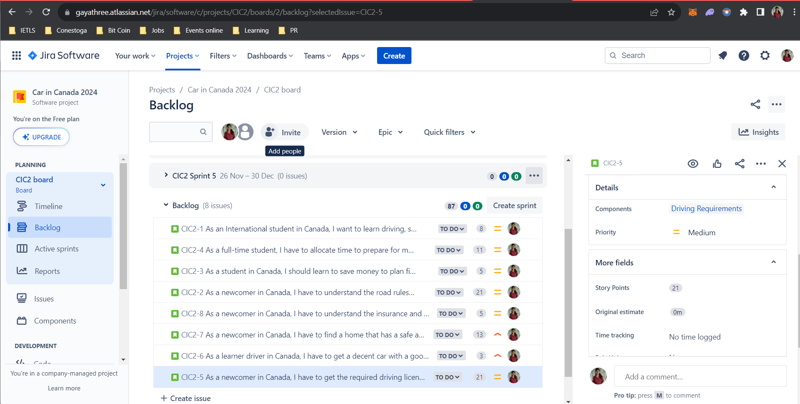

Screenshot # 2 – Create more stories if needed. There should be a minimum of 8. Make sure all the stories in your backlog are written correctly, have story point estimates, component values, and custom field values.

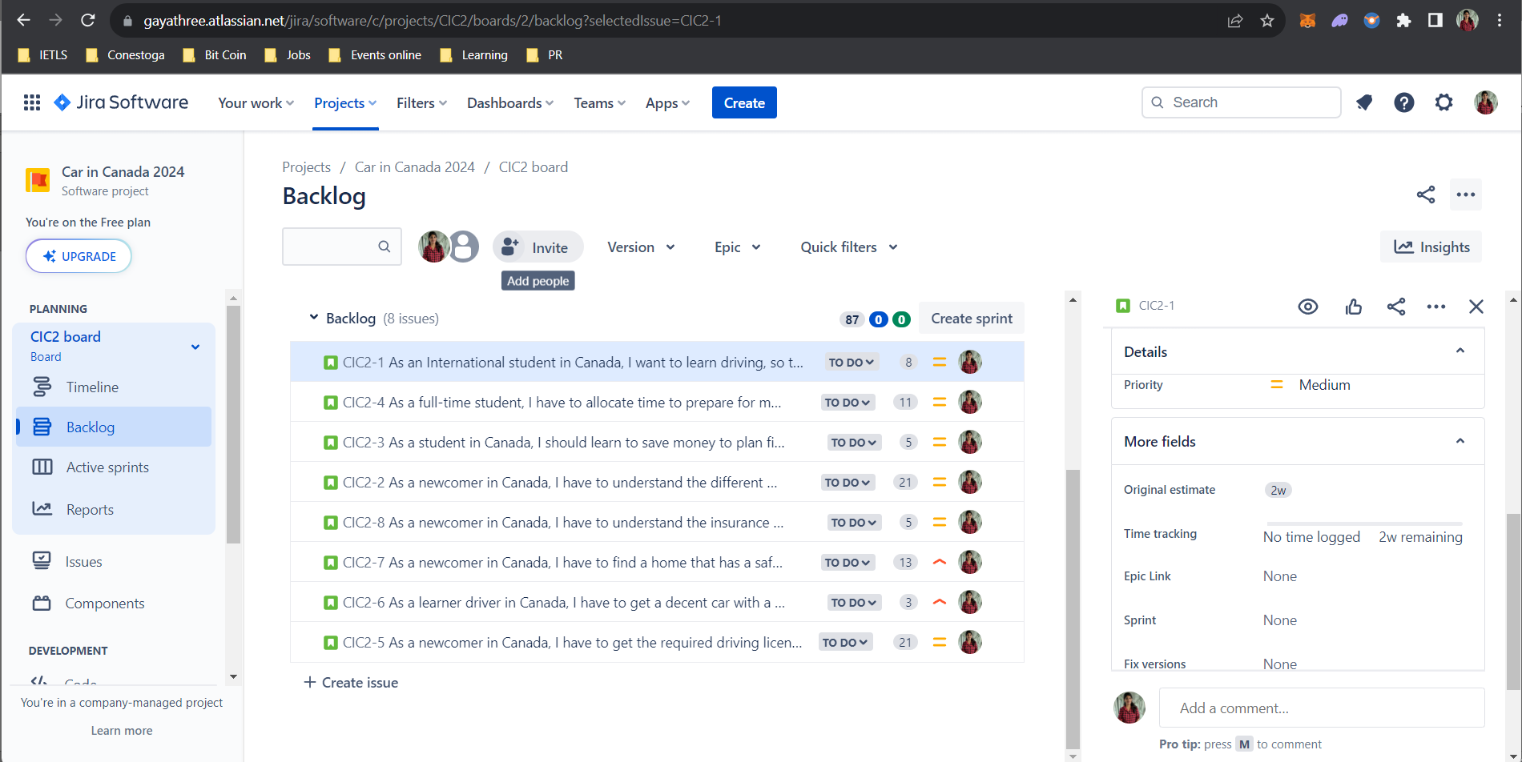

Screenshot 3 – Create at least 2 filters (basic) for your components or custom fields and at least one filter (advanced) for something of your choosing

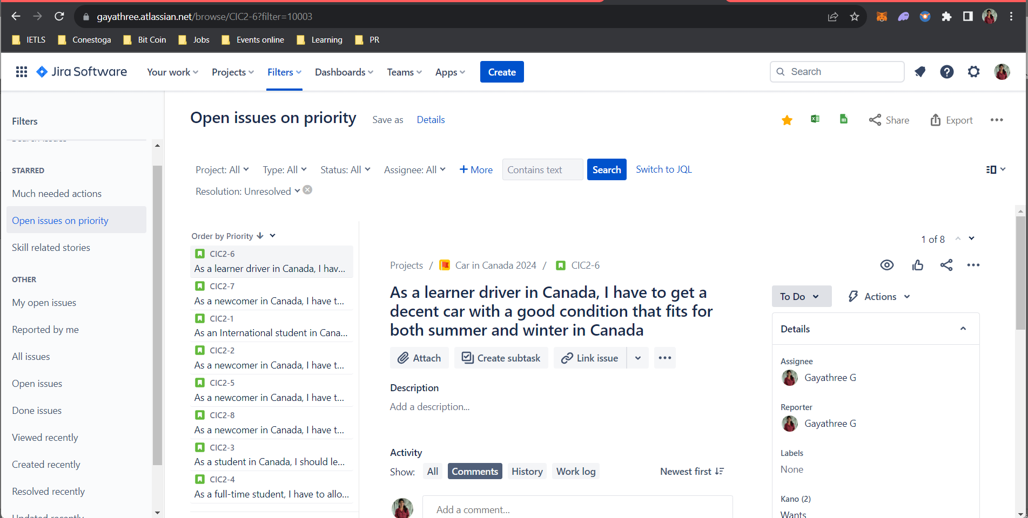

Screenshot 4 – Use one of your new filters and prove to me that it works

